AI ASSISTANT LAB-16.3
Name:V.praneeth
Rollno:2303a42146
Batch:41

Task 1 – Hospital Management Database
Scenario :
Create schema and queries for a Hospital Management System
Prompt:
Create normalized schema for Hospital Management System
Tables: Doctors, Patients, Appointments
Include primary keys, foreign keys, constraints, valid date checks

Code
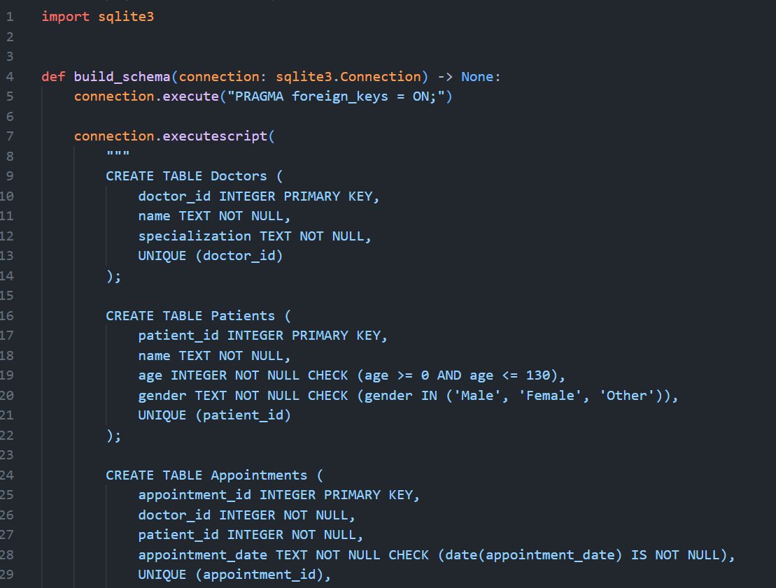
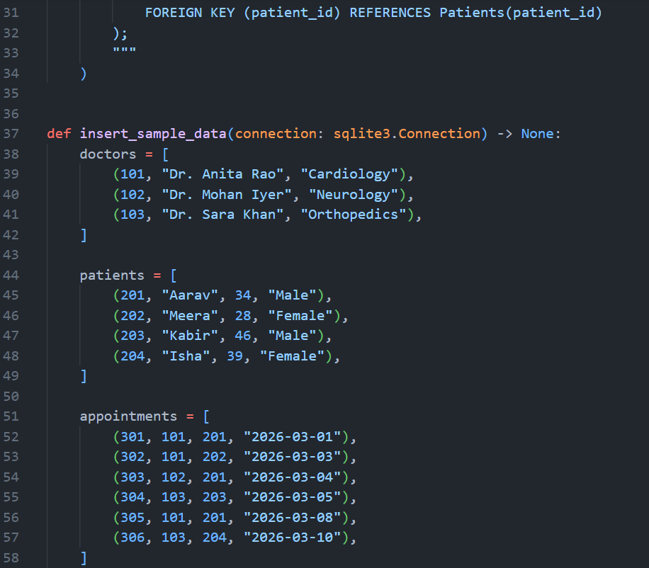
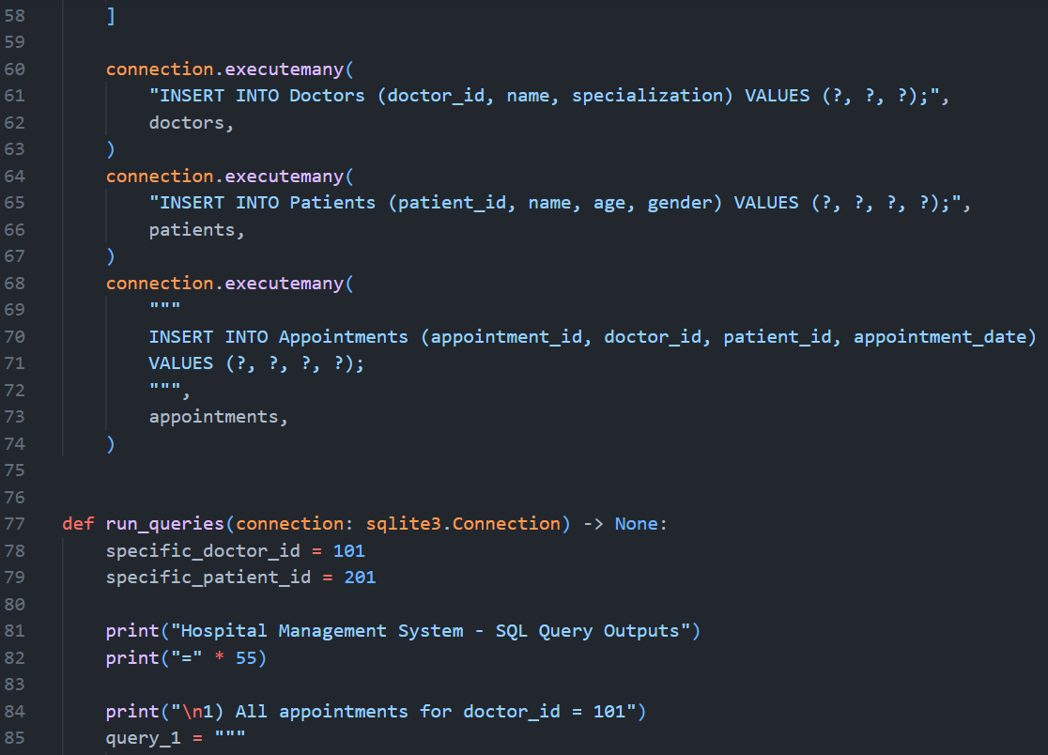
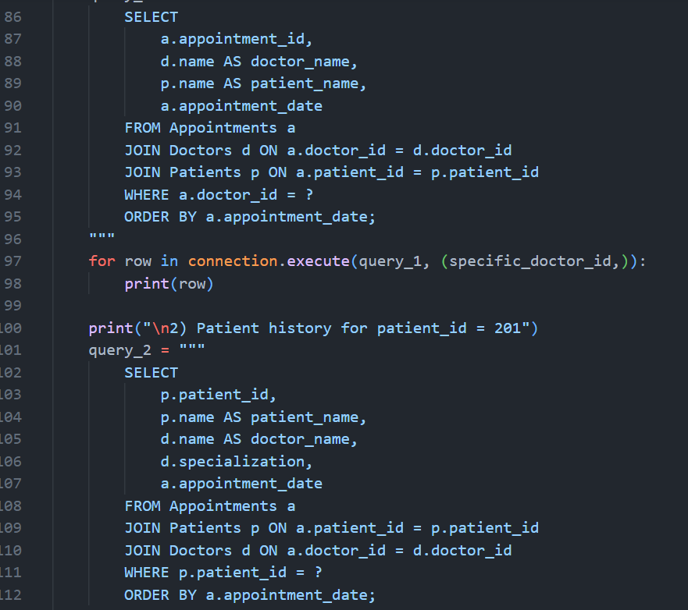
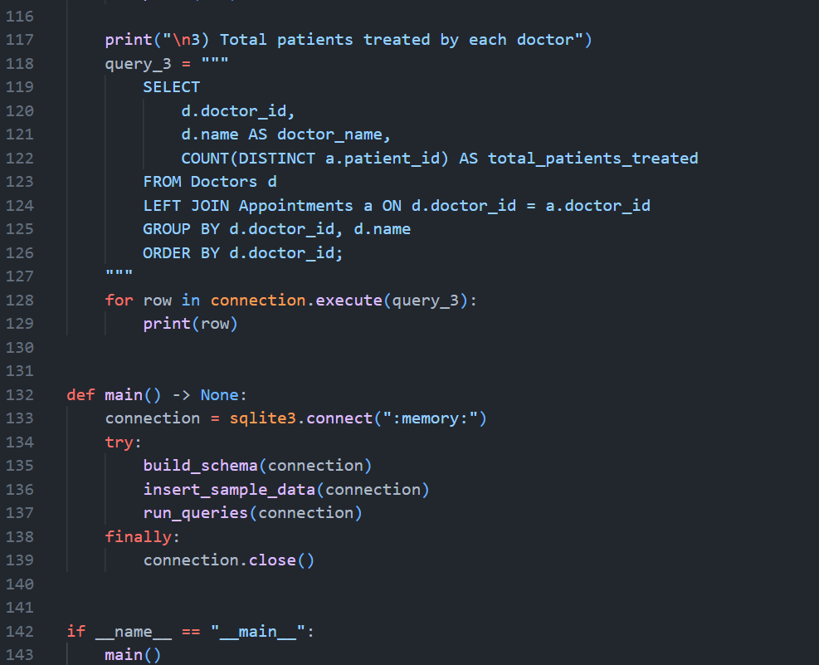
Queries and output:
Query 1:
SELECT * FROM Appointments WHERE doctor_id = 1;
Output:
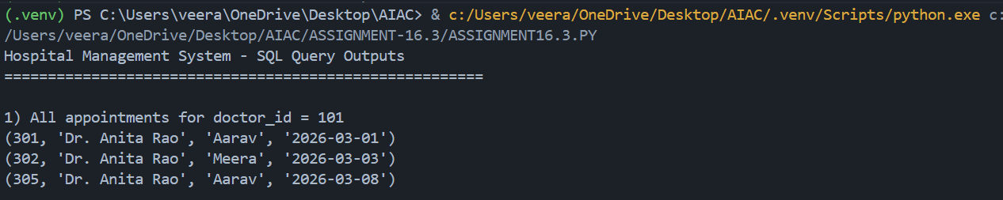

Query 2
SELECT * FROM Appointments WHERE patient_id = 1;
Output:
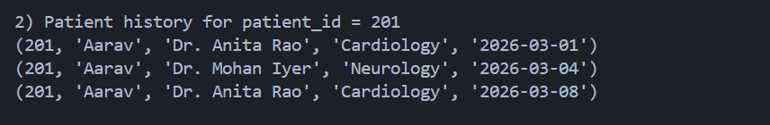
Query 3:
SELECT doctor_id, COUNT(DISTINCT patient_id)
FROM Appointments
GROUP BY doctor_id;
Output:
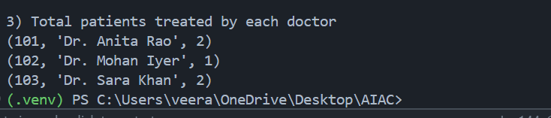
Justification:

Justification
- Copilot auto-generated FK constraints
- Ensured 3NF (no redundancy)
- Used joins implicitly via FK
Task 2 – Real-Time Application: Online Shopping Database
Scenario:
Design a database for an E-commerce platform.
Prompt:
Create schema for e-commerce system
Tables: Users, Products, Orders, OrderDetails
Include relationships and normalization
Code
import sqlite3

def create_schema(connection: sqlite3.Connection) -> None:
connection.execute("PRAGMA foreign_keys = ON;")
connection.executescript(
"""
CREATE TABLE Users (
user_id INTEGER PRIMARY KEY,
name TEXT NOT NULL,
email TEXT NOT NULL UNIQUE
);

CREATE TABLE Products (
product_id INTEGER PRIMARY KEY,
name TEXT NOT NULL,
price REAL NOT NULL CHECK (price > 0)
);

CREATE TABLE Orders (
order_id INTEGER PRIMARY KEY,
user_id INTEGER NOT NULL,
order_date TEXT NOT NULL CHECK (date(order_date) IS NOT NULL),
FOREIGN KEY (user_id) REFERENCES Users(user_id)
);

CREATE TABLE OrderDetails (
order_detail_id INTEGER PRIMARY KEY,
order_id INTEGER NOT NULL,
product_id INTEGER NOT NULL,
quantity INTEGER NOT NULL CHECK (quantity > 0),
FOREIGN KEY (order_id) REFERENCES Orders(order_id),
FOREIGN KEY (product_id) REFERENCES Products(product_id)
);

CREATE INDEX idx_orders_user_id ON Orders(user_id);
CREATE INDEX idx_orders_date ON Orders(order_date);
CREATE INDEX idx_orderdetails_order_id ON OrderDetails(order_id);
CREATE INDEX idx_orderdetails_product_id ON OrderDetails(product_id);
"""
)

def insert_sample_data(connection: sqlite3.Connection) -> None:
users = [
(1, "Asha", "asha@example.com"),
(2, "Ravi", "ravi@example.com"),
(3, "Nina", "nina@example.com"),
]
products = [
(101, "Wireless Mouse", 799.00),
(102, "Mechanical Keyboard", 2499.00),
(103, "USB-C Hub", 1499.00),
(104, "Laptop Stand", 1199.00),
]
orders = [
(1001, 1, "2026-03-01"),
(1002, 2, "2026-03-03"),
(1003, 1, "2026-03-08"),
(1004, 3, "2026-02-25"),
(1005, 2, "2026-03-14"),
]
order_details = [
(1, 1001, 101, 2),
(2, 1001, 103, 1),
(3, 1002, 102, 1),
(4, 1002, 101, 1),
(5, 1003, 101, 3),
(6, 1004, 104, 2),
(7, 1005, 103, 2),
(8, 1005, 101, 1),
]

connection.executemany("INSERT INTO Users VALUES (?, ?, ?);", users)
connection.executemany("INSERT INTO Products VALUES (?, ?, ?);", products)
connection.executemany("INSERT INTO Orders VALUES (?, ?, ?);", orders)
connection.executemany("INSERT INTO OrderDetails VALUES (?, ?, ?, ?);", order_details)

def run_queries(connection: sqlite3.Connection) -> None:
target_user_id = 1
target_month = "2026-03"

print("E-commerce Schema Query Outputs")
print("=" * 40)

print("\n1) Retrieve all orders by user_id = 1")
query_1 = """
SELECT
o.order_id,
u.name AS user_name,
o.order_date,
p.name AS product_name,
od.quantity,
p.price,
(od.quantity * p.price) AS line_total
FROM Orders o
JOIN Users u ON o.user_id = u.user_id
JOIN OrderDetails od ON o.order_id = od.order_id
JOIN Products p ON od.product_id = p.product_id
WHERE o.user_id = ?
ORDER BY o.order_date, o.order_id;
"""
for row in connection.execute(query_1, (target_user_id,)):
print(row)

print("\n2) Most purchased product (by total quantity)")
query_2 = """
SELECT
p.product_id,
p.name,
SUM(od.quantity) AS total_units_sold
FROM OrderDetails od
JOIN Products p ON od.product_id = p.product_id
GROUP BY p.product_id, p.name
ORDER BY total_units_sold DESC, p.product_id ASC
LIMIT 1;
"""
for row in connection.execute(query_2):
print(row)

print("\n3) Total revenue for month = 2026-03")
query_3 = """
SELECT
strftime('%Y-%m', o.order_date) AS revenue_month,
ROUND(SUM(od.quantity * p.price), 2) AS total_revenue
FROM Orders o
JOIN OrderDetails od ON o.order_id = od.order_id
JOIN Products p ON od.product_id = p.product_id
WHERE strftime('%Y-%m', o.order_date) = ?
GROUP BY revenue_month;
"""
for row in connection.execute(query_3, (target_month,)):
print(row)

def print_recommendations() -> None:
print("\nNormalization improvements:")
print("1. Add Categories(category_id, category_name) and reference category_id from Products.")
print("2. Split order header and payment/shipping into separate tables to avoid repeating attributes.")
print("3. Add Addresses(address_id, user_id, ...) and reference shipping_address_id in Orders.")

print("\nQuery optimization techniques:")
print("1. Index foreign keys and filter columns: Orders(user_id, order_date), OrderDetails(order_id, product_id).")
print("2. Use covering/composite indexes for frequent multi-column filters.")
print("3. Avoid SELECT * in production and return only required columns.")
print("4. Pre-aggregate monthly revenue into a summary table or materialized view for large datasets.")

def main() -> None:
connection = sqlite3.connect(":memory:")
try:
create_schema(connection)
insert_sample_data(connection)
run_queries(connection)
print_recommendations()
finally:
connection.close()

if __name__ == "__main__":
main()

Queries and output

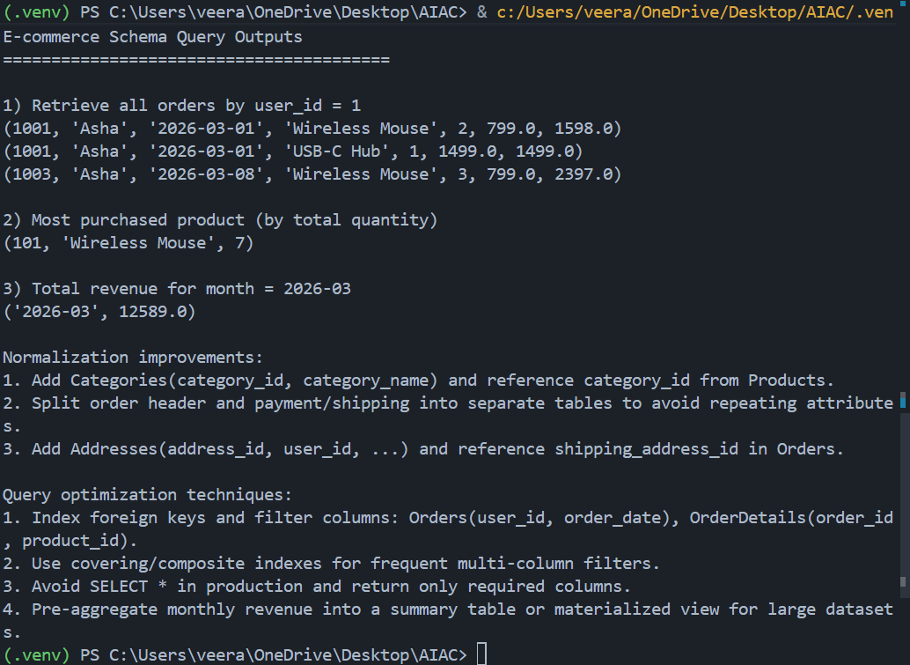
Task 3 – Library Database
Task:
Design schema for a Library Management System.
Prompt:
Create library schema
Tables: Books, Members, Loans
Suggest indexes for performance
Code
import sqlite3

def create_schema(connection: sqlite3.Connection) -> None:
connection.execute("PRAGMA foreign_keys = ON;")

connection.executescript(
"""
CREATE TABLE Books (
book_id INTEGER PRIMARY KEY,
title TEXT NOT NULL,
author TEXT NOT NULL
);

CREATE TABLE Members (
member_id INTEGER PRIMARY KEY,
name TEXT NOT NULL
);

-- return_date keeps the schema practical for "currently issued" and overdue logic.
CREATE TABLE Loans (
loan_id INTEGER PRIMARY KEY,
book_id INTEGER NOT NULL,
member_id INTEGER NOT NULL,
loan_date TEXT NOT NULL CHECK (date(loan_date) IS NOT NULL),
return_date TEXT CHECK (return_date IS NULL OR date(return_date) IS NOT NULL),
FOREIGN KEY (book_id) REFERENCES Books(book_id),
FOREIGN KEY (member_id) REFERENCES Members(member_id)
);

CREATE INDEX idx_loans_book_id ON Loans(book_id);
CREATE INDEX idx_loans_member_id ON Loans(member_id);
CREATE INDEX idx_loans_loan_date ON Loans(loan_date);
CREATE INDEX idx_loans_return_date ON Loans(return_date);
"""
)

def insert_sample_data(connection: sqlite3.Connection) -> None:
books = [
(101, "Clean Code", "Robert C. Martin"),
(102, "The Pragmatic Programmer", "Andrew Hunt"),
(103, "Design Patterns", "Erich Gamma"),
(104, "Refactoring", "Martin Fowler"),
]

members = [
(201, "Ananya"),
(202, "Vikram"),
(203, "Sana"),
]

loans = [
(301, 101, 201, "2026-02-01", None),
(302, 102, 201, "2026-03-05", None),
(303, 103, 202, "2026-01-20", "2026-02-15"),
(304, 104, 203, "2026-02-10", None),
(305, 103, 202, "2026-03-12", None),
]

connection.executemany("INSERT INTO Books VALUES (?, ?, ?);", books)
connection.executemany("INSERT INTO Members VALUES (?, ?);", members)
connection.executemany(
"INSERT INTO Loans (loan_id, book_id, member_id, loan_date, return_date) VALUES (?, ?, ?, ?, ?);",
loans,
)

def run_queries(connection: sqlite3.Connection) -> None:
print("Library Management System - Query Outputs")
print("=" * 45)

print("\n1) All books currently issued")
query_1 = """
SELECT
l.loan_id,
b.title,
b.author,
m.name AS member_name,
l.loan_date
FROM Loans l
JOIN Books b ON l.book_id = b.book_id
JOIN Members m ON l.member_id = m.member_id
WHERE l.return_date IS NULL
ORDER BY l.loan_date;
"""
for row in connection.execute(query_1):
print(row)

print("\n2) Overdue books (loan date older than 30 days and not returned)")
query_2 = """
SELECT
l.loan_id,
b.title,
m.name AS member_name,
l.loan_date
FROM Loans l
JOIN Books b ON l.book_id = b.book_id
JOIN Members m ON l.member_id = m.member_id
WHERE l.return_date IS NULL
AND date(l.loan_date) < date('now', '-30 day')
ORDER BY l.loan_date;
"""
for row in connection.execute(query_2):
print(row)

print("\n3) Number of books loaned by each member")
query_3 = """
SELECT
m.member_id,
m.name,
COUNT(l.loan_id) AS total_books_loaned
FROM Members m
LEFT JOIN Loans l ON m.member_id = l.member_id
GROUP BY m.member_id, m.name
ORDER BY m.member_id;
"""
for row in connection.execute(query_3):
print(row)

def print_design_notes() -> None:
print("\nNormalization notes:")
print("1. Books, Members, and Loans are separated into entity/relationship tables (3NF-aligned).")
print("2. Loan rows store only references (book_id, member_id), preventing book/member data repetition.")
print("3. Optional extension: move author names to an Authors table if multiple books share the same author.")

print("\nIndexing strategy for faster queries:")
print("1. Index Loans(book_id) for joins to Books.")
print("2. Index Loans(member_id) for member-history and aggregation queries.")
print("3. Index Loans(loan_date) and Loans(return_date) for overdue/currently-issued filters.")
print("4. Optional composite index Loans(member_id, loan_date) for timeline-based member reports.")

def main() -> None:
connection = sqlite3.connect(":memory:")
try:
create_schema(connection)
insert_sample_data(connection)
run_queries(connection)
print_design_notes()
finally:
connection.close()

if __name__ == "__main__":
main()
Queries and output:
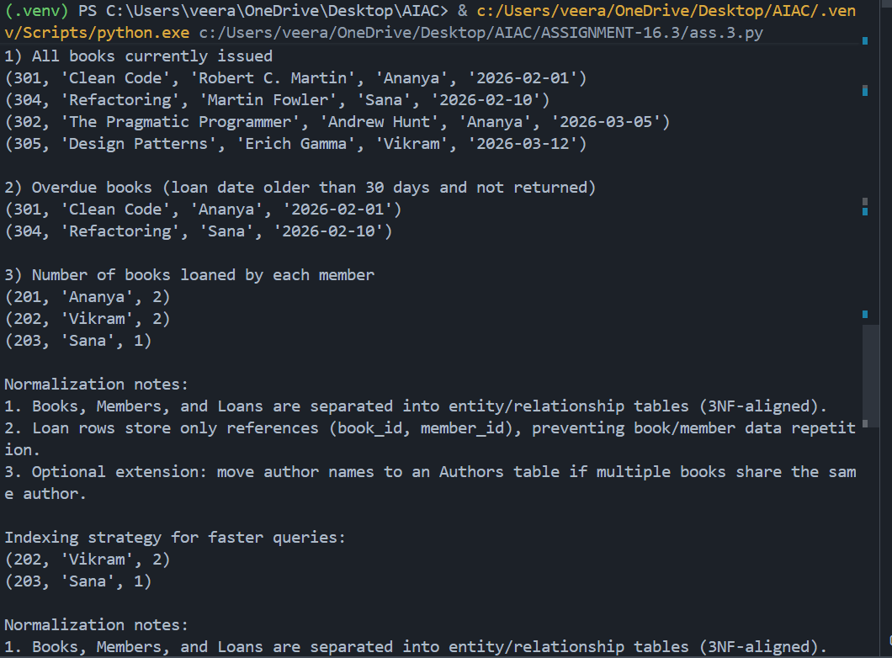
Justification
Index improves search speed
Copilot suggested indexing on date column
Task 4: Optimize Queries
Instructions:
• Use AI tools to analyze query efficiency.
• Optimize inefficient queries using joins, indexes, or reducing subqueries.
• Test optimized queries for correctness.
Starter Code Example:
-- Original query
SELECT * FROM Books WHERE author_id IN (SELECT author_id FROM
Authors WHERE country='UK');
-- Optimized query
SELECT b.*
FROM Books b
JOIN Authors a ON b.author_id = a.author_id
WHERE a.country = 'UK';
Prompt : ptimize query using JOIN instead of subquery
Code
-- Original
SELECT * FROM Books WHERE author_id IN
(SELECT author_id FROM Authors WHERE country='UK');

-- Optimized
SELECT b.*
FROM Books b
JOIN Authors a ON b.author_id = a.author_id
WHERE a.country='UK';
-- Original
SELECT * FROM Books WHERE author_id IN
(SELECT author_id FROM Authors WHERE country='UK');

-- Optimized
SELECT b.*
FROM Books b
JOIN Authors a ON b.author_id = a.author_id
WHERE a.country='UK';
Output:
book_id | author_id | title | category
------- | --------- | --------------------------------------- | ----------
101 | 1 | 1984 | Fiction
102 | 2 | Harry Potter and the Philosopher's Stone| Fantasy
Justification
JOIN reduces nested query overhead
Faster on large datasets
Task 5: University Course Registration
Scenario:
SR University needs a course registration system for students enrolling in
different courses under faculty supervision.
• Use Copilot to design schema tables: Students, Courses, Faculty, and
Registrations.
• Define relationships:
• Each student can register for multiple courses.
• Each course is taught by a faculty member.
• Write SQL queries to:
• List all students enrolled in a specific course.
• Find faculty members teaching more than 2 courses.
• Retrieve courses with the highest number of registrations
Prompt:
ceate schema for Students, Courses, Faculty, Registrations
Define relationships and constraints
Code
import sqlite3

def create_schema(connection: sqlite3.Connection) -> None:
connection.execute("PRAGMA foreign_keys = ON;")
connection.executescript(
"""
CREATE TABLE Students (
student_id INTEGER PRIMARY KEY,
name TEXT NOT NULL
);

CREATE TABLE Faculty (
faculty_id INTEGER PRIMARY KEY,
name TEXT NOT NULL
);

CREATE TABLE Courses (
course_id INTEGER PRIMARY KEY,
course_name TEXT NOT NULL,
faculty_id INTEGER NOT NULL,
FOREIGN KEY (faculty_id) REFERENCES Faculty(faculty_id)
);

CREATE TABLE Registrations (
registration_id INTEGER PRIMARY KEY,
student_id INTEGER NOT NULL,
course_id INTEGER NOT NULL,
FOREIGN KEY (student_id) REFERENCES Students(student_id),
FOREIGN KEY (course_id) REFERENCES Courses(course_id),
UNIQUE (student_id, course_id)
);

CREATE INDEX idx_courses_faculty_id ON Courses(faculty_id);
CREATE INDEX idx_registrations_student_id ON Registrations(student_id);
CREATE INDEX idx_registrations_course_id ON Registrations(course_id);
"""
)

def insert_sample_data(connection: sqlite3.Connection) -> None:
students = [
(1, "Aarav"),
(2, "Meera"),
(3, "Kabir"),
(4, "Isha"),
(5, "Rohan"),
]

faculty = [
(101, "Prof. Sen"),
(102, "Prof. Nair"),
(103, "Prof. Das"),
]

courses = [
(201, "Database Systems", 101),
(202, "Data Structures", 101),
(203, "Operating Systems", 101),
(204, "Machine Learning", 102),
(205, "Computer Networks", 103),
]

registrations = [
(301, 1, 201),
(302, 2, 201),
(303, 3, 201),
(304, 1, 202),
(305, 4, 202),
(306, 5, 203),
(307, 2, 204),
(308, 3, 204),
(309, 4, 204),
(310, 1, 205),
]

connection.executemany("INSERT INTO Students VALUES (?, ?);", students)
connection.executemany("INSERT INTO Faculty VALUES (?, ?);", faculty)
connection.executemany("INSERT INTO Courses VALUES (?, ?, ?);", courses)
connection.executemany("INSERT INTO Registrations VALUES (?, ?, ?);", registrations)

def run_queries(connection: sqlite3.Connection) -> None:
specific_course_id = 201

print("University Course Registration - Query Outputs")
print("=" * 50)

print("\n1) Students enrolled in course_id = 201")
query_1 = """
SELECT
s.student_id,
s.name AS student_name,
c.course_name
FROM Registrations r
JOIN Students s ON r.student_id = s.student_id
JOIN Courses c ON r.course_id = c.course_id
WHERE c.course_id = ?
ORDER BY s.student_id;
"""
for row in connection.execute(query_1, (specific_course_id,)):
print(row)

print("\n2) Faculty members teaching more than 2 courses")
query_2 = """
SELECT
f.faculty_id,
f.name,
COUNT(c.course_id) AS courses_taught
FROM Faculty f
JOIN Courses c ON f.faculty_id = c.faculty_id
GROUP BY f.faculty_id, f.name
HAVING COUNT(c.course_id) > 2
ORDER BY f.faculty_id;
"""
for row in connection.execute(query_2):
print(row)

print("\n3) Courses with the highest number of registrations")
query_3 = """
WITH course_counts AS (
SELECT
c.course_id,
c.course_name,
COUNT(r.registration_id) AS total_registrations
FROM Courses c
LEFT JOIN Registrations r ON c.course_id = r.course_id
GROUP BY c.course_id, c.course_name
)
SELECT
cc.course_id,
cc.course_name,
cc.total_registrations
FROM course_counts cc
WHERE cc.total_registrations = (
SELECT MAX(total_registrations) FROM course_counts
)
ORDER BY cc.course_id;
"""
for row in connection.execute(query_3):
print(row)

def print_normalization_notes() -> None:
print("\nNormalization summary:")
print("1. Students, Faculty, and Courses are separate entity tables.")
print("2. Registrations resolves the many-to-many relation between Students and Courses.")
print("3. Course-to-faculty is one-to-many via Courses.faculty_id, avoiding redundant faculty data.")

def main() -> None:
connection = sqlite3.connect(":memory:")
try:
create_schema(connection)
insert_sample_data(connection)
run_queries(connection)
print_normalization_notes()
finally:
connection.close()

if __name__ == "__main__":
main()

Query and output:
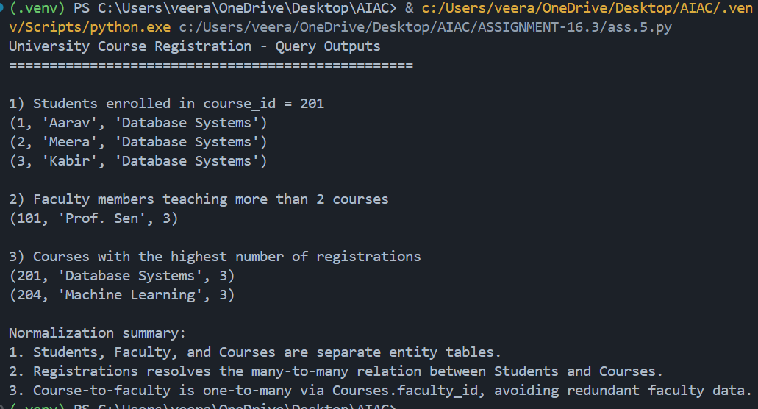

Justification
Copilot ensured many-to-many mapping
Queries optimized with JOIN + GROUP BY

